CHRISTOPHER C. CHARLES
3460 Keele St, Toronto, Ontario, M3J lL9
Tel (416) 398-3772
cccharlee@yahoo.com, http://drpcdr.ca

CAREER OBJECTIVE: Pharmacy Dispensing Assistant

PRACTICAL PHARMACY SKILLS:
- Fluent in English and French
- Good interpersonal, verbal and written and customer service skills in English
- Interpreted and filled prescriptions for drug therapy as supervised by pharmacist
- Entered customer records using computerized dispensing system
- Invoiced insurance companies covering cost of medication
- Operated cash register. Collected payment from clients
- Measured, compounded, packaged and labeled drugs
- Cleaned and sterilized equipment
- Ordered, received, rotated, restocked and stored phamaceutical products and supplies
- Returned damaged expired or recalled drugs to manufacturer and disposed waste

ACCOMPLISHMENTS:
Assisted teacher of Pharmacy Dispensing Assistant course by supplying medical VHS tapes

EDUCATION:
Toronto District School Board Pharmacy Dispensing Assistant 2006
Algonquin College Biochemical Technology 1987

TRAINING:
Certificate: Cardio-Pulmonary Resusitation 2006
Canadian Red Cross

Seminar: Kroll Pharmacy Software 2006
Seminar: Alzheimer Society 2006

Christopher C. Charles (416) 398 3772 Page 2

RELEVANT WORK EXPERIENCE:

Hands on Experience:
- Pre-packaged medications (including unit dose packaging)
- Received and interpreted written prescriptions
- Cleaned and sterilized dispensing bottles and instruments
- Directed customers to products sold in the pharmacy or referred them to the pharmacist

Pharmacy Dispensing Skills:
- Interpreted doctor’s order, prescriptions and requests
- Good knowledge and understanding of the Canadian drug industry
- Provided technical and clerical support to pharmacists
- Knowledge of community and hospital pharmacy operations and procedures

Retail and Customer Service Skills:
- Suggested appropriate product or service by identifying customer’s need
- Assisted and satisfy hostile complaining customers while following policy and procedures
- Established solid business relationship with clients and suppliers

Administrative/Technical Skills:
- Provided excellent service/support via telephone

FIELD PLACEMENT EXPERIENCE:

Pharmacy Dispensing Assistant 2006
Drugstore Pharmacy
Moss Park Pharmacy

WORK HISTORY:

1999 - Present Dr PC SELF-EMPLOYED, Toronto area
2004 PC Technician COMPUTERS FOR SCHOOLS, Mississauga
1999 Customer Service Rep ALEA GROUP, Richmond Hill
1998 Inside Sales Rep PHONETTIX INTELECOM, Toronto
1997 Telesurvey Rep CANTRACK RESEARCH, Toronto
1997 Customer Service Rep KELLY placement @ IBM, Toronto
1997 Customer Service Rep CEBRA @ WATTS COMM., Etobicoke

REFERENCES AVAILABLE UPON REQUEST

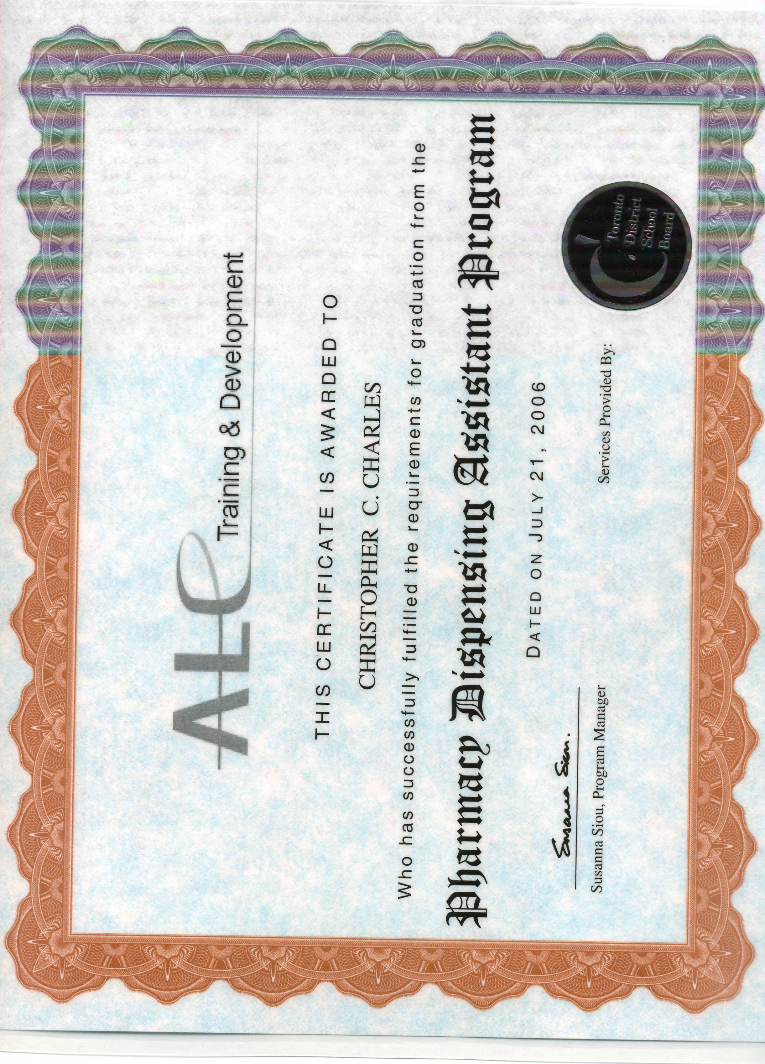

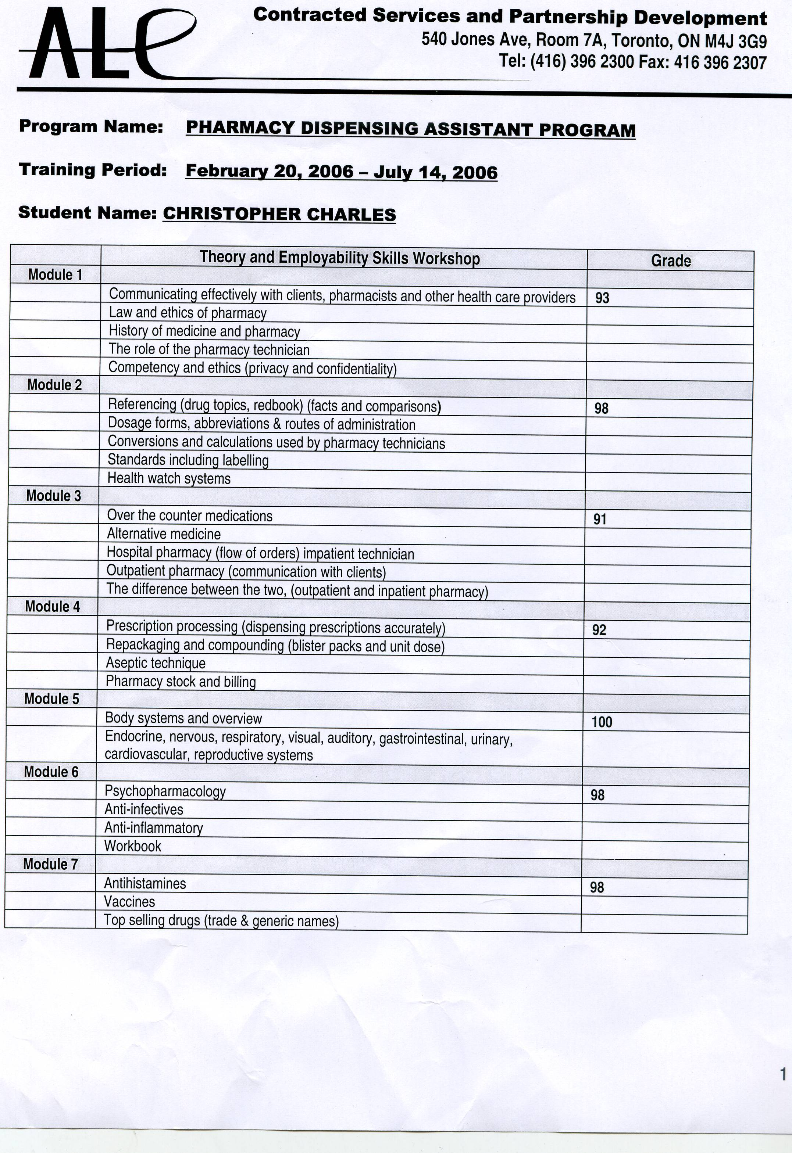

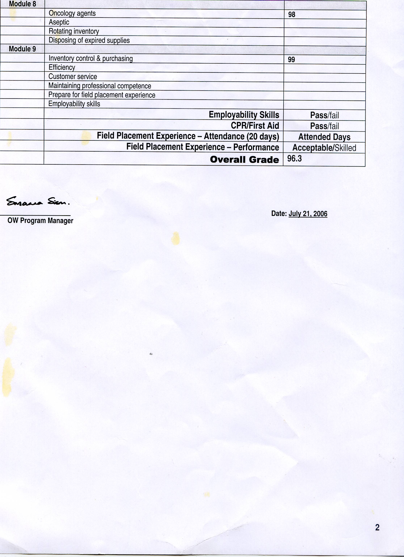



Contracted Services & Partnership Development

540 Jones Avenue, Room 7A, Toronto ON M4J 3G9

Tel: (416) 396-2300 Fax: (416) 396-2307

August 3 2006

Dear Manager:

This letter confirms that Christopher Charles is registered in the Employer Incentive Pharmacy Dispensing Assistant Program with the Toronto District School Board & ALC Training & Development.

The incentive is provided to increase the client’s opportunity to obtain
employment and demonstrate their ability to contribute to your organization.

You the employer is eligible to receive a Financial Incentive of $2,500

A few simple pieces of paper work need to be completed prior to client starting their new position. For more information about our program, please contact me anytime. This letter is valid for sixteen weeks after the date of issuance.

Yours truly,

Celina Manzano
Job Developer
ALC Training & Development
540 Jones Avenue, Room 7A
Toronto, Ontario
M4J 3G9
Tel: (416) 396-2303
Fax: (416) 396-2307



